FALL, 2014
VINCENT SMITH SCHOOL
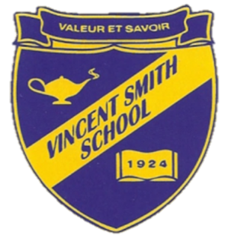
Believe and Achieve…It’s Okay to Learn Differently

Upcoming Events
September 3 – Welcome Back Barbeque

Important Announcement

Students, Families, Faculty, Administrators and Alumni

Join us on Wednesday, 9/3 from 5:00 pm – 7:00 pm for our “Welcome Back Barbeque” being held on the School campus.

322 Port Washington Blvd., Port Washington, NY 11050
www.vincentsmithschool.org T: 516-365-4900
Dear VSS Parent,
I am excited about meeting with your children, getting to know them and I thank you for trusting us with their education.
The Vincent Smith School is a community of learning, enrichment and support, and I look forward to working closely with each family as we approach the 2014-2015 school year.
Best wishes,
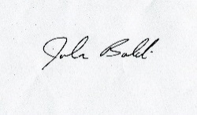
John Baldi
Head of School

More Important News
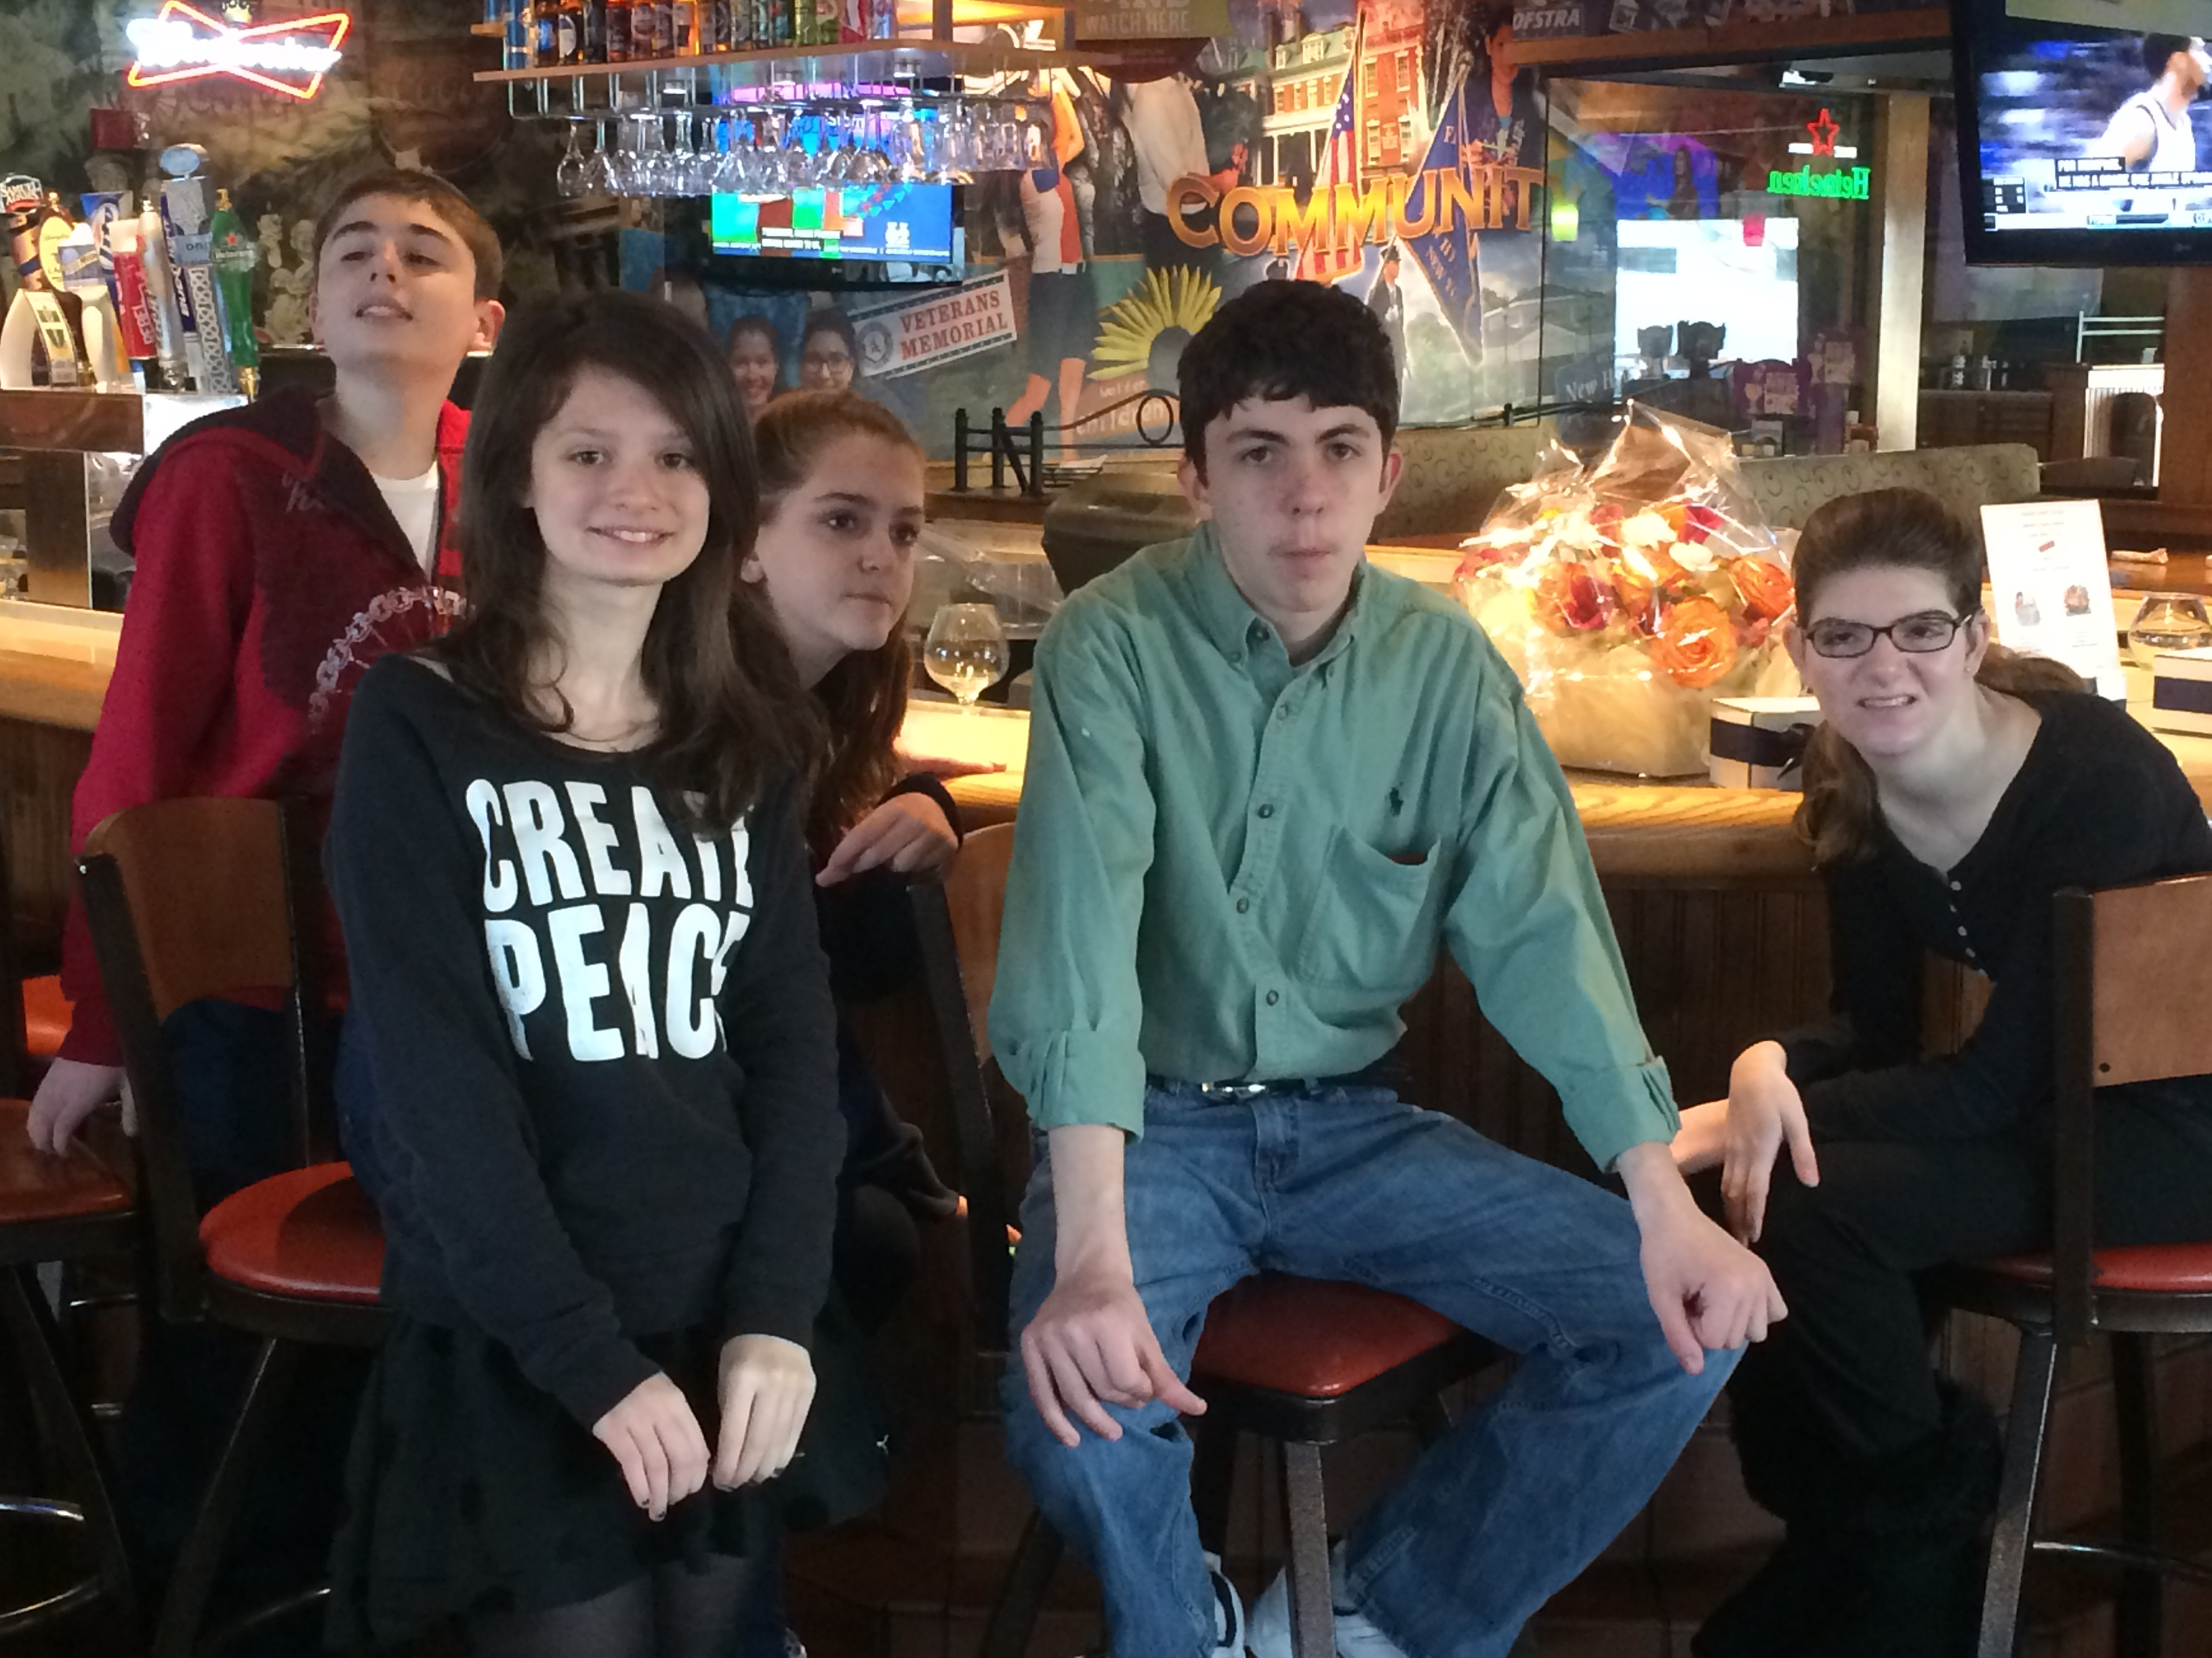

SAVE THE DATE
The School is looking for Admissions Open House volunteers – parents and students to help provide tours to prospective students and their families, answer questions and provide first-hand testimonials on your experiences with the Vincent Smith School. Interested? Email Michelle Hughes, mhughes@vincentsmithschool.org or call (516)365-4900, ext. 115

Admissions Open House Dates:

Saturday, October 25, 2014
Noon -3 PM
Saturday, March 7, 2015
Noon-3 PM
and
Wednesday, May 6, 2015
7-9 PM
Call or email Michelle Hughes
(516) 365-4900, ext. 115
mhughes@vincentsmithschool.org

The school is undergoing a Beautification Project – work has begun and will be completed prior to the start of school. The project entails:
A new front entrance on Port Washington Blvd.,
Removal of the “traffic circle” immediately after you enter the school property and appropriate re-paving,
Designated walkways and a widened entrance to the lower lot; Lower School exterior and a new 4 foot fence on the southwest side, replacing the current fence,
Middle School bathroom renovations,
Lower School kitchen floor.

To meet the needs of the community, a Business Advisory Board was recently created. The Board is comprised of professional business people who will act as our advocates with their constituencies, spreading the word about Vincent Smith School, helping with events and fundraising. If you or someone you know is interested in joining, please ask them to contact Michelle Hughes – mhughes@vincentsmithschool.org – (516) 365-4900, ext. 115
GRADUATION
Graduation is always a special time at VSS. This year we honored our three 2014 graduates:

Brian Siegel
Justin Wolder
Yusuf ZaffarUllah
Congratulations to each of you and your families! Wishing each of you a bright future filled with happiness and prosperity!

###

Welcome to John Baldi, New Head of School
Mr. Baldi officially starts on July 1, 2014. He was formerly the Director of Finance at the Kew-Forest School, a Pre K-12 independent school in Queens. He earned his B.A in Accounting from Queens College, his M.S. in Education from St. John’s University and he is currently pursuing and completing his Doctoral degree in Instructional Leadership. His research and dissertation involves the effect of introducing Science, Technology, Engineering and Math (STEM) education to middle school students. He resides in Floral Park with his wife, Theresa, a special education teacher for the NYC Dept. of Education and is the father of two children, Nicholas and Olivia. Welcome!

A Preview of What is Happening This Coming Year…
Welcome Back Barbeque 9/3
Back to School Night 9/18
School Portraits 9/22 (rain date 9/29)
All School Walk a-thon 10/17
Special Person’s Day (Grades 4-8) 9/23
College/Career Night (Sophomore/Junior Parents) 1/7/15
Senior Dinner 5/14
Field Day 5/22

Please check our online calendar on the website for additional events, test dates, etc.
The online calendar contains information about the PTA, their meeting dates, fundraisers, etc. Meetings are held once a month; we encourage parents to become active participants in the PTA –
Doing good for the School is doing good for your child!

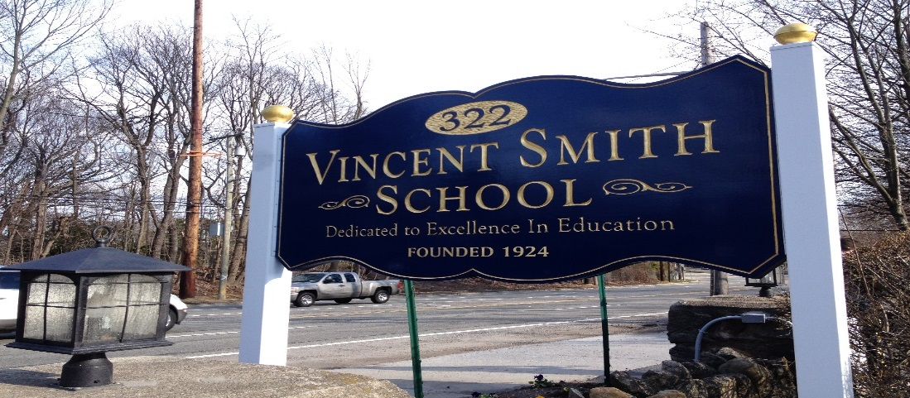

The Past Year in Review
VSS Unveils New Website – www.vincentsmithschool.org
Senator Martins Visits School - http://vincentsmithschool.org/News/senator-jack-martins-visits-vincent-smith-school/21
Career Fair - http://vincentsmithschool.org/News/vss-career-fair-a-successful-and-informative-event/3
VSS and WGBB Radio - http://vincentsmithschool.org/News/student-eva-hersho-on-wgb-radio/23
Island Harvest Food Drive -http://vincentsmithschool.org/News/vincent-smith-school-students-donate-food-for-holidays-to-island-harvest/19
School Visit to Tenement Museum - http://vincentsmithschool.org/News/vss-students-visit-tenement-museum-ny/24
Applebee’s Flapjack Fundraiser Breakfast
Career Fair
Earth Day - http://vincentsmithschool.org/News/vincent-smith-school-celebrating-earth-da/34
Arlene Wishnew – Women of Distinction Award - http://vincentsmithschool.org/News/arlene-wishnew-receives-honorable-mention-at-women-of-achievement-event/38
Lord & Taylor Fundraising Event - http://vincentsmithschool.org/News/shop-smart-do-good-lord-taylor-manhasse/28
wit&whim Fundraiser - http://vincentsmithschool.org/News/may-is-vincent-smith-school-month-at-wit-whim-gift-sho/25
Ben’s Deli Fundraiser - http://vincentsmithschool.org/News/support-vincent-smith-school-when-you-shop-at-bens-del-on-52314/41
School Beautification Project with Morgan Stanley and Home Depot - http://vincentsmithschool.org/News/morgan-stanley-volunteers-teams-up-with-vss/37
Field Day
Senior Dinner at Thyme
ISTEP Partners with VSS to Provide Soccer - http://vincentsmithschool.org/News/soccer/44
Broadway Shows - Motown and Cinderella
Friday Finales

ANNOUNCEMENTS
Congratulations to Mrs. Lauren Rosario on her appointment to School Principal. Wishing you continued success, Mrs. Rosario!
Mrs. Grace Avigliano has decided to accept another teaching position within the public education sector. She will not be returning to the Vincent Smith School in the fall. A search is currently underway for a replacement.

Over the past nine years, Mrs. Avigliano has brought passion, integrity and the highest of standards to the position of Director of Special Education. We wish her continued success in her new role and will miss her insight and dedication to the School, the students and the families of the Vincent Smith School.

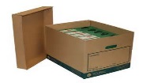Tiana Taliep, Vincent Smith School Archivist, has been unanimously voted to be a board member of the North Shore Historical Museum. Tiana’s tenure on the board is for two years.

James Demsky will be returning as our 7th and 8th grade Math/Science teacher. James is an avid ball player and active on his softball team.
Jessica Del Latto will be the new 7th and 8th grade Social Studies/English Language Arts instructor. She is certified in Social Studies (7-12) and Special Education (7-12). Jessica graduated from Molloy College with a B.A. in Social Studies Adolescent Education & Special Education (7-12) with Honors. Welcome Jessica!

Susan Steinberg is a Speech Language Pathologist who will be supervising
- Team Building I – grades 4-6
- Team Building II – grades 7-8
- Vocational Exploration- grades 9-10
- College/Career Counseling- grades 11-12

A warm welcome to Mrs. Peggy Spacek, Office Manager and Registrar. Stop by the office and say hello to Peggy! Peggy loves to cook and has been busy this summer getting the office ready for the school opening day on September 4th! She is the driving force behind the “Welcome Back to School” family barbeque!

